 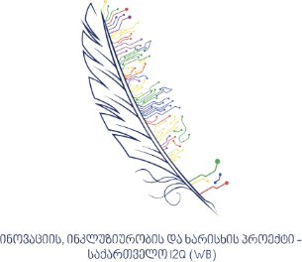

**LEPL Iakob Gogebshvili Telavi State University**

**Faculty of Agrarian, Natural Sciences and Technologies and**

**Innovation, Inclusion and Quality Project in Georgia I2Q ​​(CIF)**

**International Scientific Conference**

**,,Application of Modern Technologies in Agriculture“**

**27-28 March 2025**

We are honored to invite you to the scientific conference "Application of Modern Technologies in Agriculture" planned within the framework of the international project "Integration of Innovative Agrotechnologies into Educational Programs" (CIF), which will be held on March 27 and 28, 2025 at Iakob Gogebashvili Telavi State University, organized by the Faculty of Agrarian, Natural Sciences and Technologies.

The conference is open to relevant academic staff, scientists and doctoral students in the agricultural field.

The conference will include plenary presentations and will be held in a hybrid mode (face-to-face and online), the working languages ​​are Georgian and English.

Participation in the conference is free (funded by the project).

Those wishing to participate in the conference should send their abstracts on the conference topic by February 28 of this year to the following address: elene.dzamiashvili@tesau.edu.ge

The conference abstracts will be published as an electronic collection. Conference participants will receive a bilingual (Georgian and English) certificate.

Speakers will be selected based on abstracts and notified by email by March 10, 2025.

The thesis must be presented in Georgian and English. (For International participants on in English language)

The thesis must include the following components:

Title of the report (maximum 15 words);

Name, surname, scientific degree, position, phone number, e-mail of the presenter;

Number of keywords - 5;

Maximum number of words in each thesis (Georgian, English) - 300. Font Sylfaen, font size - 12. Interval between lines - 1.0; Standard margins: left - 3 cm, right - 1.5 cm, top - 2 cm, bottom - 2 cm;

The conference includes plenary reports and an excursion.

We look forward to your participation and valuable contributions!

Best regards,  
**Conference Organizing Committee**  
Iakob Gogebashvili Telavi State University